


REPORT WRITING
Subject: Internet Software Architecture
Application Prototype-1 Report

Weather Forecast Website

Module Leader Report prepared by
Mr Bishal Khadka Rajib Shrestha
Level4Group2
Student ID:2614040

Reflective Report on the Strengths and Weaknesses of the Weather That I have build over the last 3 weeks
This report reflects all of the strengths and weaknesses of the Weather website. This Website is built using HTML , CSS and JavaScript . It uses data from the OpenWeather API. The Api key which is used on my website is 657e0b31bbbba7312aa87d01de1e8fc8 .
The website follows a simple structure where user enter the name of the city and the data is changed if the city name is found in Open weather Api if not the error is shown in the screen saying “Invalid city name”. The front end is responsible for user interaction and presentation, while weather data is retrieved asynchronously from an external API using asyn function in JavaScript .
Now talking about the strength and weakness of this website are :
Strengths:
- It has simple UI .
- It has user friendly interface.
- It has search city functionality.
- The code is easy to debug as it has low line of code maximum reaching about 400 lines.
- The data will not be need to be stored in own database as it is used from Openweather Api.
- It is responsive for the most as long as the Open weather Api works.
- Uses function like async() and Fetch() to get data.

Weakness:
- It uses Api key form open weather Api which may not work in certain instances which will make the whole website unresponsive.
- It does not have sunrise and sunset and other need data which can be available with some line of code.
- It does not have the hourly weather detail and the 7day details which might have been possible with some line of code.
- It does not have local storage so offline mode is not available.
- It does not have any backend optimization which makes it vulnerable .
- It can only handle low amount of users.
- It is heavily dependent on a single Api key.
The above given information are from my personal experience building the website. It may have more weakness about it which I will be improving in future protypes.

UML DIAGRAM AND FLOW CHART DIAGRAMS ARE GIVEN BELOW: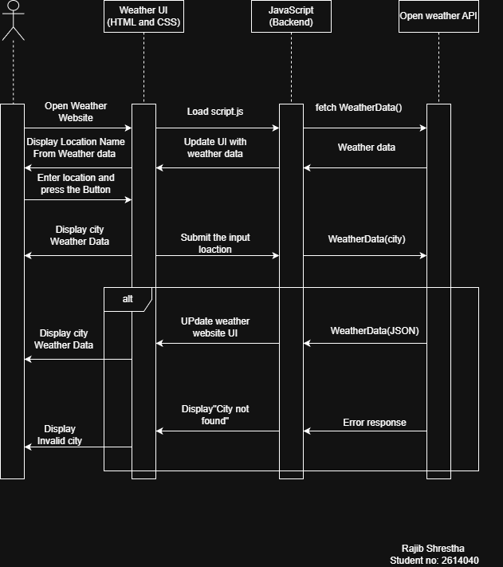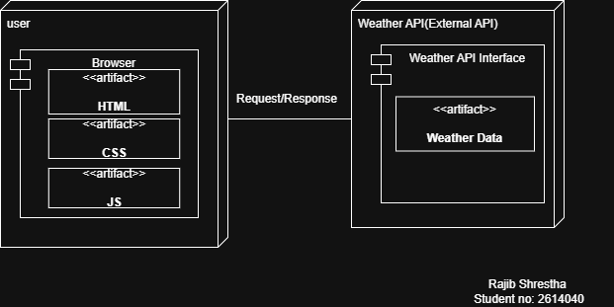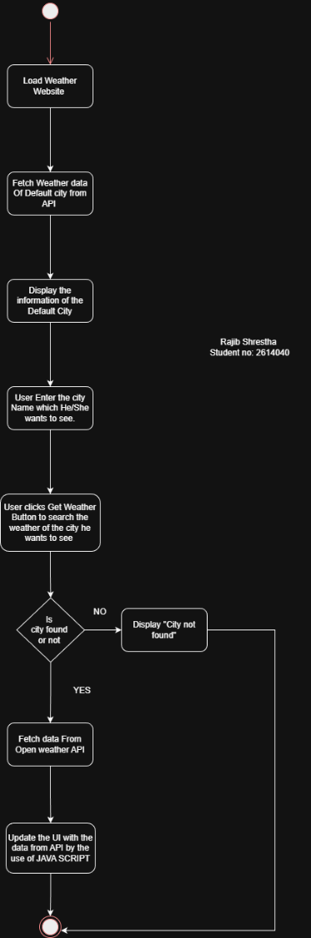
Thank you Herald College for giving me this amazing chance to show my expertise in this field and teaching me how to do so with amazing guidance and opportunities like this. Hope my performance will improve studing in Herald college .

